Pre-Construction Public Meeting

Meeting Location: Glenview Village Hall – Burnham Board Room
2500 East Lake Avenue
Glenview, IL 60026

Meeting Date & Time: March 9, 2023, 2023 at 6:00 pm – 6:45 pm

Subject: Prairie Lawn Road Construction Project – Prairie Lawn Road from Glenview Rd.
to Linneman St.
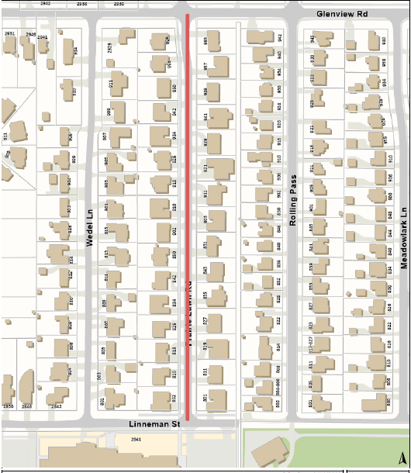

The Village of Glenview Community Development Department, Engineering invites all residents along Prairie Lawn Road to a pre-construction meeting at which the following topics will be discussed:

- Proposed improvements as part of the Capital Improvement Program:
  - New Water Main installation with new 1 ½ inch water services and b-boxes
  - Storm Sewer Improvements
  - Sanitary sewer repairs
  - Road construction
  - Parkway Restoration

- Construction Schedule

- FAQs regarding construction

Village staff will share final plans and will be available to discuss the project schedule, logistics and answer questions. In the next few week’s, you may see the contractor on your street mobilizing equipment and material, as well as workers from JULIE placing flags and marking the locations of underground utilities.
If you unable to attend or would like to meet at later date, please contact epugh@glenview.il.us or 847-904-4235 to arrange a meeting.

Once the construction commences project updates will be posted on the Village’s website at:
https://www.glenview.il.us/Pages/Spruce%20Reconstruction.aspx

Staff Contacts: Eric Pugh, Project Manager, (847) 904-4235
Adriana Webb, Engineering Division Manager, (847)904-4414

